**Python-api-Challenge - VacationPy**

**Heat map**

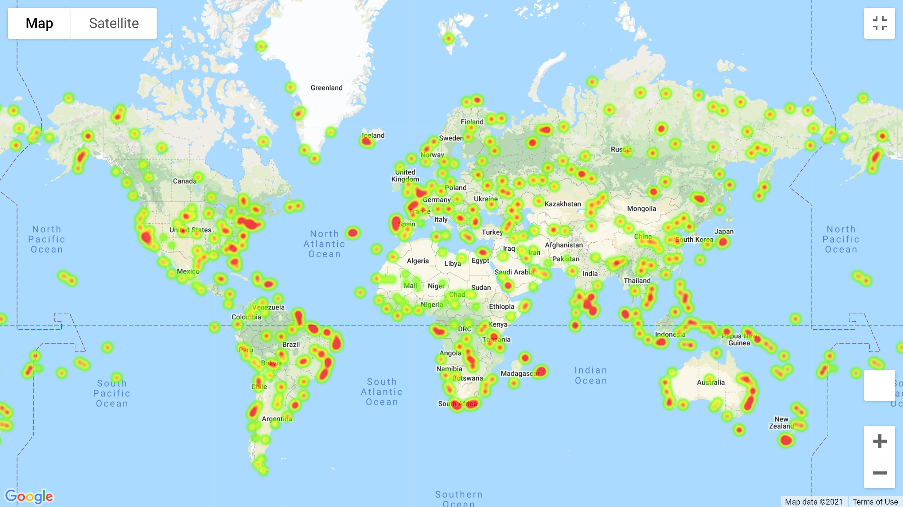

**Heat map with markers**

